**Lab Rats Inc.**

Project Plan

# GPO’s and Security

# Date: 4 June 2023

**This Report was prepared by:**

**Andrew Waddell**

**andwadde@uat.edu**

# Executive Summary

### Introduction to the report

Setting up GPO’s and Security.

### Project Report

Detailed report.

# Introduction

This report is generated from the NTW216 contract to Lab Rats Inc., work order number 20200217006. This report is to showcase the reasoning behind using Windows Server 2019 for the Lab Rats Inc. needs. From here on Lab Rats Inc. shall be referred to as “The Company,” for the remainder of the report.

# Project Report

The Company requires a new infrastructure setup with specific needs. They are planning a global storage plan to include corporate documentation, sensitive financial information, employee records, user, documents and departmental related information. They require a File Server to share resources according to corporate guidelines. There will be multiple organizational units for the various departments such as legal, IT, HR, and accounting. Figure 1 shows the creation of the different organizational units for said purposes as well as a created user for the required department. In addition, group policies will be implemented based on the needs of the company such as password management, approved web browsers, and anti-virus.

Figure 1 showcases the creation of the group policy management, titled Security Settings.

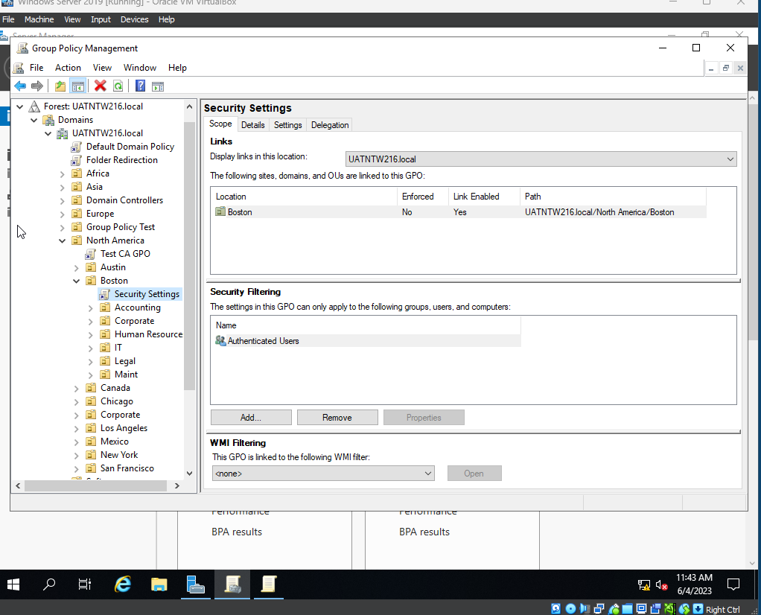

Figure 1. GPO.

Figure 2 shows the password policy enforcement. Per company regulation. All passwords must be 12-14 characters, meet complex needs, cannot be used in the last 10 changes, and must be changed every 60 days. Complete configuration is shown in Figure 3.

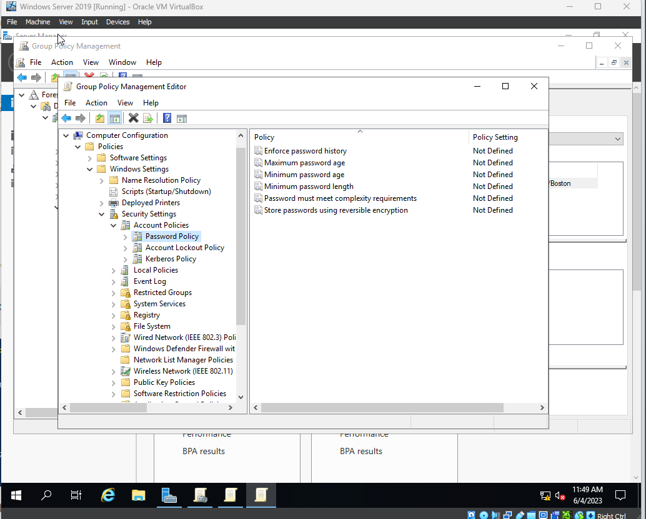

Figure 2. Password Management.

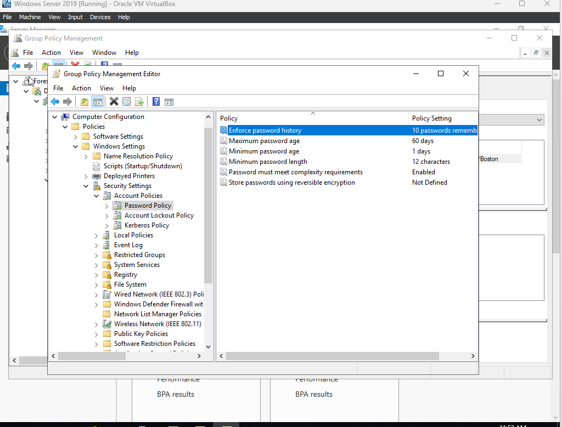

Figure 3. Password Configuration

The Company has dictated that the monthly financials will be utilized as the desktop wallpaper for all users to see. Figure 4 showcases the ability to do this. Note, the path is not a real path as I was having trouble getting files to upload on the VM.

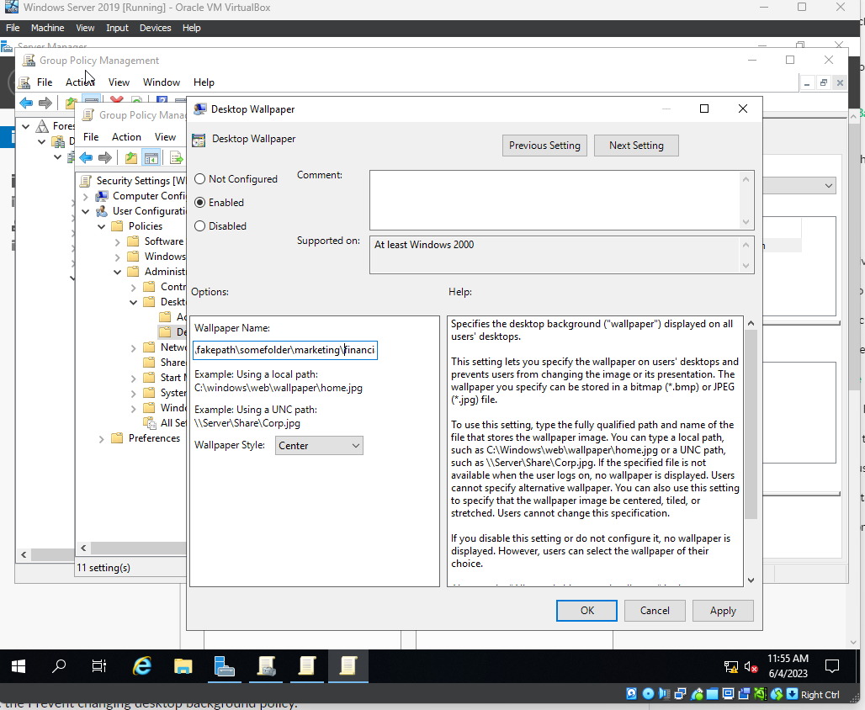

Figure 4. Financial Wallpaper.

The Company has also mandated that Google Chrome be the only authorized web browser to be used. Figure 5 showcases the configuration for that process. However, my virtual setup refuses to let me share files and folders no matter the configuration I use. Even from help with Google and Microsoft, I still cannot get it to work properly. I have provided a different picture of where the settings will be located for setting Google Chrome as a default web browser in figure 5.

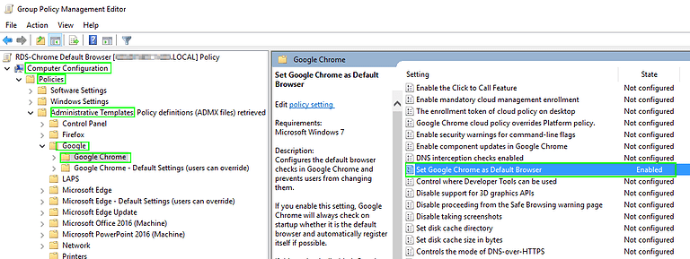

Figure 5. Google Chrome Web Browser.

Figure 6.0 – 6.2 showcases the configuration for allowing web access to Google Chrome from a public domain. The process is the same for denying access through the configuration wizard.

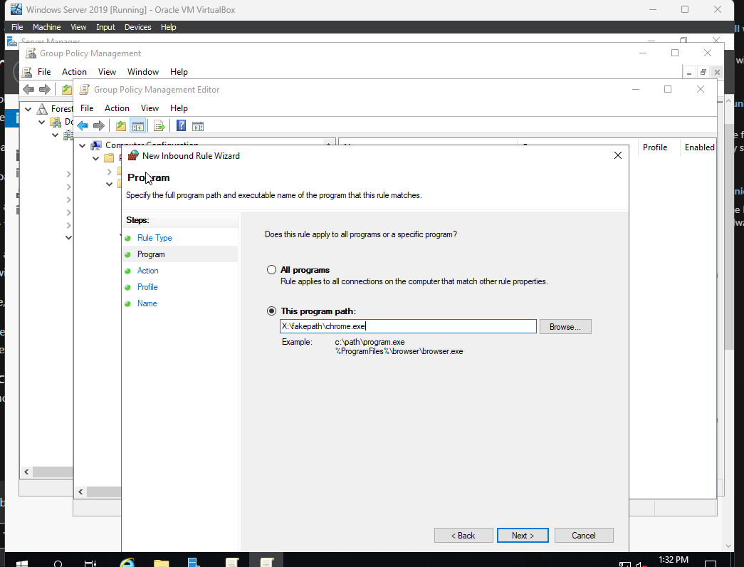

Figure 6.0

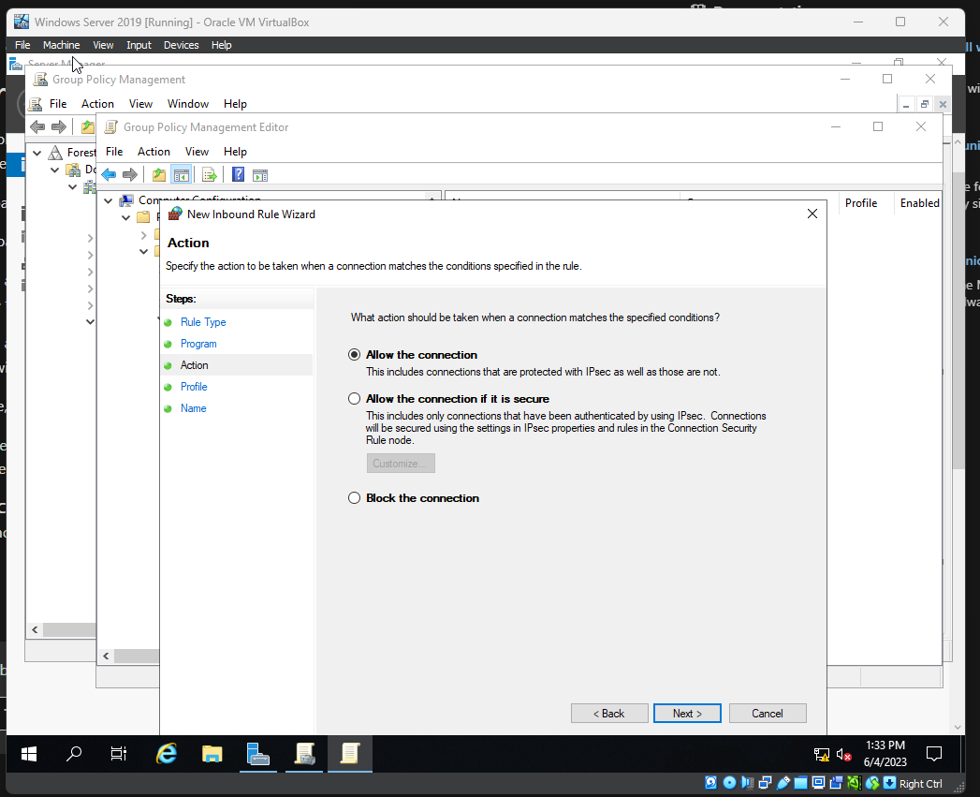

Figure 6.1

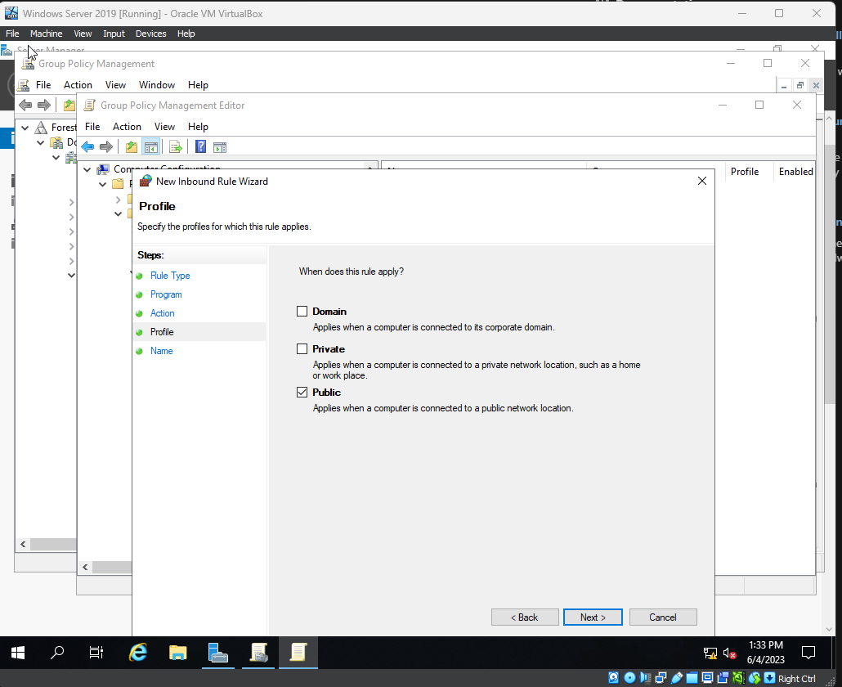

Figure 6.2

Anti-Virus is configured within the group policy under computer configuration > admin templates policy > windows components > Microsoft Defender Anti-Virus. From here I am able to ensure it is updated constantly as well as installed correctly.

Lastly, for remote access. This can be configured through the firewall inbound/outbound rules. Much as the same as allowing web access through a public domain. Shown in Figure 7.



Figure 7.